Good Practices Template

PICA’s Agricultural projects in the Republic of Nicaragua and Republic of El-Salvador

[Tagline - Summarize the spirit of the project in a single phrase (tag line)- up to 20 words]
Transferring Palestinian Agricultural development Knowledge to Nicaragua and Al-Salvador.

[Which Sustainable Development Goal(s) does the initiative address?]
- SDG #1 end poverty and SDG #2 Zero Hunger: End Hunger, achieve food security and improve nutrition and promote sustainable agriculture.
Target #2.5
By 2020, maintain the genetic diversity of seeds, cultivated plants and farmed and domesticated animals and their related wild species, including through soundly managed and diversified seed and plant banks at the national, regional and international levels, and promote access to and fair and equitable sharing of benefits arising from the utilization of genetic resources and associated traditional knowledge, as internationally agreed.
Target #2.4
By 2030, ensure sustainable food production systems and implement resilient agricultural practices that increase productivity and production, that help maintain ecosystems, that strengthen capacity for adaptation to climate change, extreme weather, drought, flooding and other disasters and that progressively improve land and soil quality.

Metadata
Project name: Transferring Palestinian Agricultural development Knowledge to Nicaragua and Al- Salvador
Countries/territories/regions involved: Nicaragua and Al- Salvador.
Nominated by:
Sustainable Development Goal target(s):SDG#1 and SDG #2 Target 2.5 and 2.4.
Supported by:
Implementing entities: Palestinian International Cooperation Agency (PICA)
Project status (ongoing or completed): Ongoing.
Project period (indicate the time frame of its implementation (start and end year) (2018 exploratory mission) Implementation: 2019 – 2024.

URL of the practice:
https://m.facebook.com/story.php?story_fbid=2561288170782219&id=1685156701728708&sfnsn=mo
https://tn8.tv/nacionales/463742-palestina-apoyara-nicaragua-mejoramiento-genetico-agricola/
https://www.el19digital.com/articulos/ver/titulo:97064-nicaragua-saluda-aniversario-de-independencia-de-palestina
https://m.facebook.com/story.php?story_fbid=2736706843223511&id=1739624326265106&sfnsn=mo
https://www.elsalvador.com/eldiariodehoy/con-apoyo-tecnico-palestina-estrecha-lazos-con-el-salvador/665076/2019/
Describe the Challenge the “best practice” is addressing/addressed? (100 - 150 words)

This section should provide an overview of the challenge in the country or region in which the initiative is being implemented in (or has been implemented) and what is required to address it for the achievement of one or more of the SDGs.

Central America's economy is composed of two main economic sectors: agriculture and mining. Land, minerals and tropical and temperate climates make it ideal for growing a variety of agricultural products. It is the potential for economic growth.
Both Nicaragua and El Salvador have been prioritized the focus on improving agricultural technologies and techniques to boost both quality and efficiency. The improvement will strategically strengthen the economy and has a direct effect on peoples living standers and Self-sufficiency.

The challenge faced is high resource consumption including Human resources and natural resources. The Project equipping the livestock and agricultural engineers with the proper knowhow to elevate the public and private service in agriculture, throughout the most recent artificial insemination, aquaponic, silage production, greenhouses management, pest control, food processing, and production.

Towards a Solution (600-700 words)
In this section, kindly ensure the following ‘questions’ are addressed in the submission:
(Please do not answer the questions directly under each question but address them in the 600-700 text in the “insert text here” section) These questions sever as guidance when drafting the text. Please ensure they are addressed).

1- What does the initiative aim to achieve in response to the challenge(s)? Please indicate all the relevant SDG(s) the solution aims to address.

2- How did the initiative lead to the systemic, cross-country transfer of the good practice and knowledge between two or more countries of the South for their mutual benefit to overcome the transnational development challenges that is difficult to overcome singlehandedly?

3- What methodology has been used to address the challenge that led to a successful outcome and in accelerating/achieving the SDG(s)? How was the process participatory between the partners? what were their concerted actions?

4- What were the outcomes achieved in relations to the SDG(s) targets? (please include quantitative data that highlights the outcomes)

5- How was the good practice innovative? How did it improve countries competitive advantage?

6- How was the good practice sustainable? did it lead to any policy impact, cooperation agreements, regional integration efforts etc. to ensure its long-term sustainability?

7- How is the good practice replicable? What are the possibilities for the good practice to be extended more widely? What conditions need to be met to ensure its replicability?

Insert text here: (600-700 words)

PICA designed agricultural programs aim to elevate the knowledge accessible to local farmers to produce on an individual basis in small scale projects to increase families' income production of healthy crops in integrated agricultural societies as well as efficient and effective use of resources. Taking into consideration wastewater management through the promotion of sustainable use and consumption of resources.

The project aims to contribute toward achieving SDG #1 End poverty in all its forms everywhere and SDG #2 End hunger, achieve good security and improved nutrition and promote sustainable agriculture.

Overall the project aim to achieve the following:

• Increase farmer’s income.
• Produce healthy food.
• To enhance the capabilities of agricultural cadres, raise their capacities and improve agricultural production.
• To equip the livestock engineers with both theoretical and practical aspects of Aquaponic and silage making.
• Spreading awareness of the importance of applying biosecurity in farms, institutions, and laboratories, the importance of early detection of veterinary diseases through laboratory testing and taking appropriate samples.
• Disseminate the improved genetic traits of elite male males by using artificial insemination techniques to improve meat and milk productivity.

To cover the above objectives, each project phase deploy accumulative practical training courses for local farmers and engineers in the following topics:
• SMALL SCALE AQUAPONIC PRODUCTOIN AND SILAGE MAKING.
• HOME MADE FOOD MANUFACTURING.
• INNOVATE TECHNIQUES FOR TOMATO, CUCUMBER AND PEPPER CULTIVATED UNDER GREENHOUSES AND VEGETABLE GRAFTING.
• THE BIOSECURITY, RISK ANALYSIS AND IN THE LABORATORY.
• ARTIFICIAL INSEMINATION IN CATTLE, SHEEP AND GOAT.

This bilateral cooperation between PICA and both the Republic of Nicaragua and El Salvador has shown great momentum led by the good practices and recent knowhow owned by the Palestinian experts. Which systematically transferred the knowledge through strategic programs that overcome specific needs and challenges with minimum resources usage in the field of water and agriculture.
The Palestinian knowhow is specialized in maximizing results out of limited resources. We’ve been able to provide engineering tools, processes and techniques assuring overall boost in quality and efficiency

In Order to be able to strategize a plan to fulfill exact needs, PICA starts the program with exploratory missions to assess local need; the delegation consisted of agricultural engineers and senior government experts, who all will work with the relevant ministers of health, agriculture, economical sectors in the host countries. All the Palestinian efforts coordinated by PICA.

The delegation along with key players in the host countries drafted the needs assessment. The methodology used is by collecting information from local engineers and farmers, observing current farming techniques, weighting potential economical choices, listening to the current challenges faced, and then draft the suitable goals and timeline to fulfill the needs. We prioritized continues feedback before, during and post each phase of the project, after building the network between PICA’s experts and local engineers and farmers feedbacks are dynamic remotely (using all technological ways possible such as Skype calls, emails… Etc.) and in the field. There is continuous monitoring of results and how locals are deploying the knowledge in farms. We also make sure to include all team members in the evaluation process after each phase of the project to adapt collective measures if needed and invite new questions and solutions.

The outcomes achieved after the first phase of the project is training 120+ engineers in the above-mentioned courses in Nicaragua. During the 2nd phase of the project and throughout 8 working days in Nicaragua 140+ local engineers participate in the training courses. In El- Salvador throughout 5 working days 110+ trainees participate. During the second phase only, PICA was able to reach out and coach more than 250 agricultural engineers, vets as well as agricultural entrepreneurs who are all fully or partially involved and employed by the ministries of agriculture or the affiliated centers and agencies.

Good administrative, logistical, and technical practices were adopted to increase the quality of the mission including the very efficient communication channels created, qualitative indicating the quality of the programs in terms of satisfying the existing need and assessing the quality of materials, tools, and programs. Moreover, managerial cooperation was sat to place to ensure restructuring the programs relevant departments that intersect with the Palestinian program to ensure strategic cooperation that transfer the knowledge to the government staff and simultaneously reach the network to the simple farmer.

The effective use of the existing resources, materials and market was the number one constraint for the Palestinian experts, so all the services and products within all the fields could be produced locally both in Nicaragua or El-Salvador within a needy market. Thus, in 5 years Nicaragua, for example, could build the capacities of more than a thousand technical staff and improve their networking modules between farmers, societies and the government, equipped with the most recent, productive, efficient and effective knowhow that can be practically placed in houses, farms, schools, and factories.

PICA has signed many cooperation agreements in health, agriculture, and education as well as a general memorandum of understanding with an umbrella for the different fields of cooperation with the Nicaraguan Ministry of Foreign Affairs. PICA has therefore launched two agricultural missions to capacitate the Nicaraguan counterparts with the Palestinian knowhow, which will sustain at least a 5-year plan in the already existing fields of cooperation as well as cooperation in the fields of irrigation, water and wastewater management, and any other agricultural need that the Palestinians can satisfy. PICA also assured the reach of this cooperation to the educational institutes which included medical cooperation with the university of UNAN by recording lectures in orthopedics for the 4th year medical school orthopedic program which will overlap with the practical cooperation for the scoliosis surgeries that will be operated in Nicaragua soon. During the upcoming phases, we are planning to cooperate more with educational faculties in both El Salvador and Nicaragua and link them with Palestinian agricultural engineering academic and research institutions and to deploy student\professors exchange.

PICA promotes to design replicable missions and sustainable cooperation within the country and across the continents within principles of geographical clustering of cooperation and best utilization of resources while maintaining the quality of the missions. The clustering of missions can be widely beneficial through deploying customized but similar programs in tested before in countries with similar needs and resources.
Also, within the same host country, replication of the processes will be smooth due to a clear systematic needs assessment, strategy, and dynamic monitoring system.

Contact details
What is the address of the people or the project to contact if you want more information on the good practice?
  - Name: Hiba Ismail
  - Title: Diplomat, Program officer
  - Organization: Palestinian international cooperation agency (PICA) - Ministry of forging affairs.
  - Email address: Hismail@mofa.pna.ps
  - Skype ID or Whatapp/Wechat number (optional)
Skype: hiba.m.ismail
Whatsapp: +970598353603

Please include 3-4 High Resolution Photos for the initiative
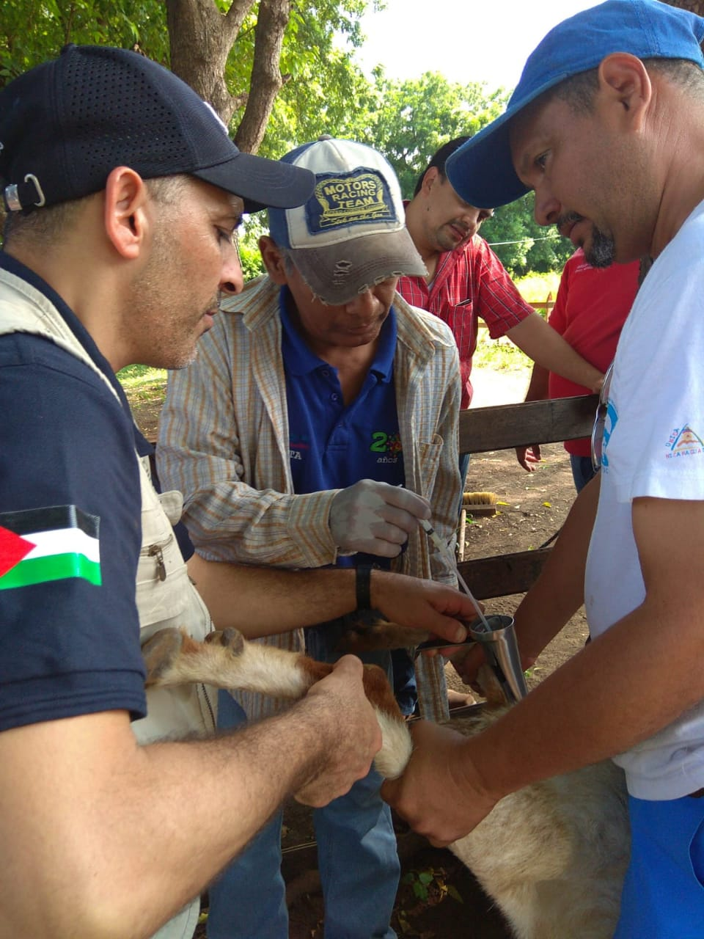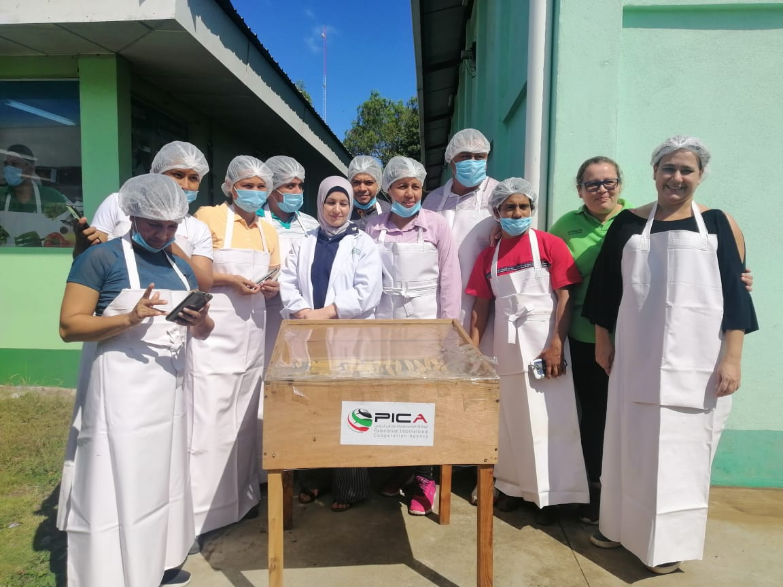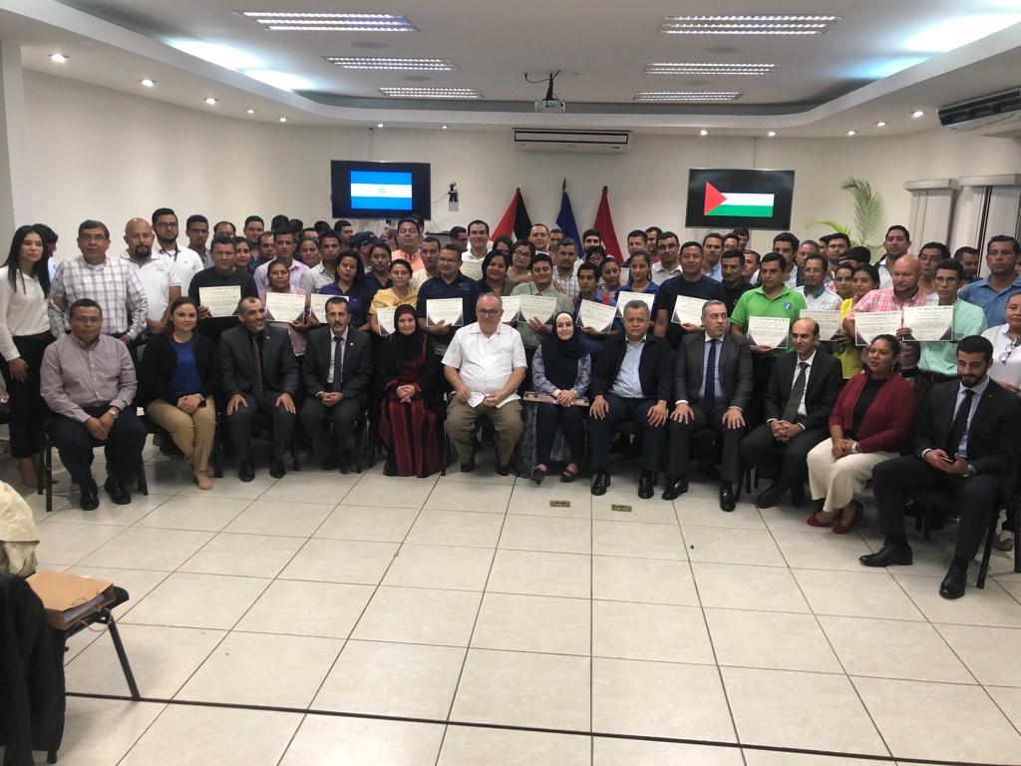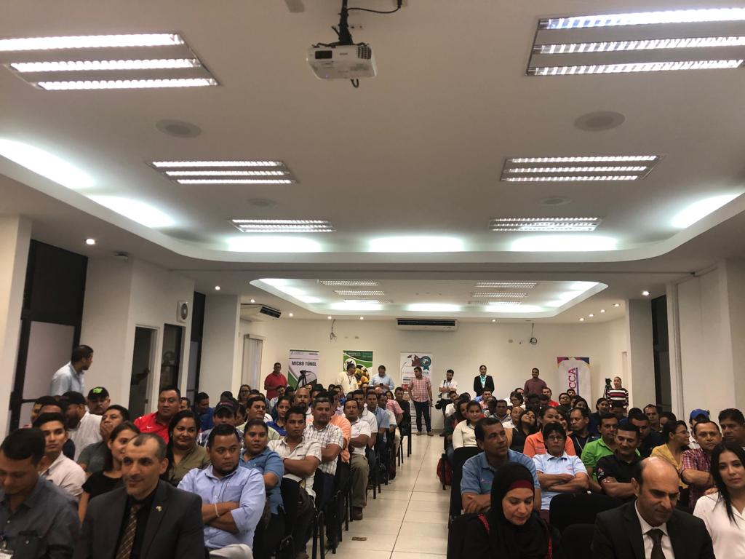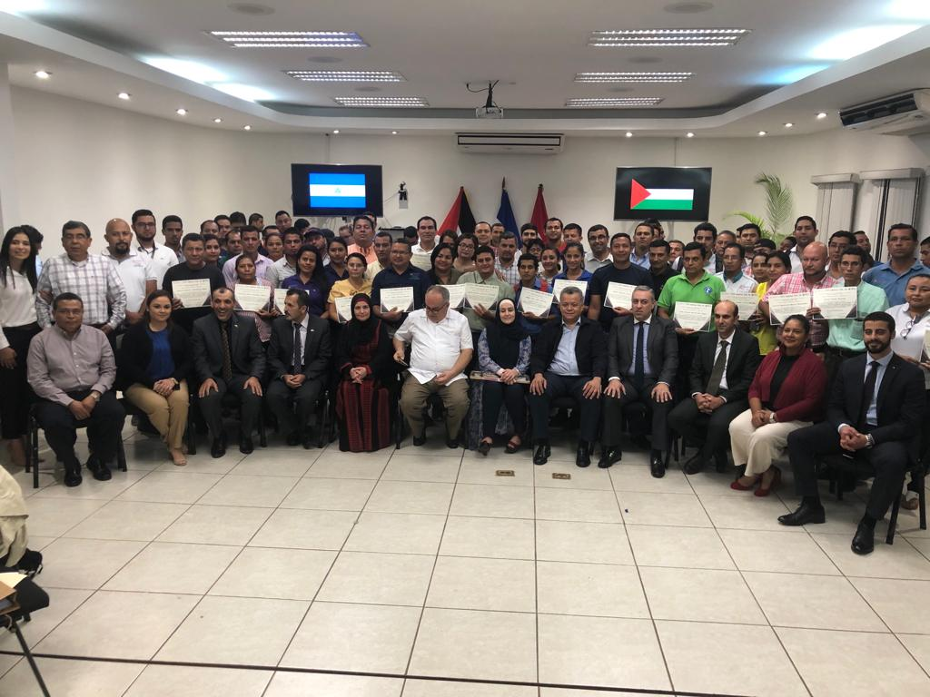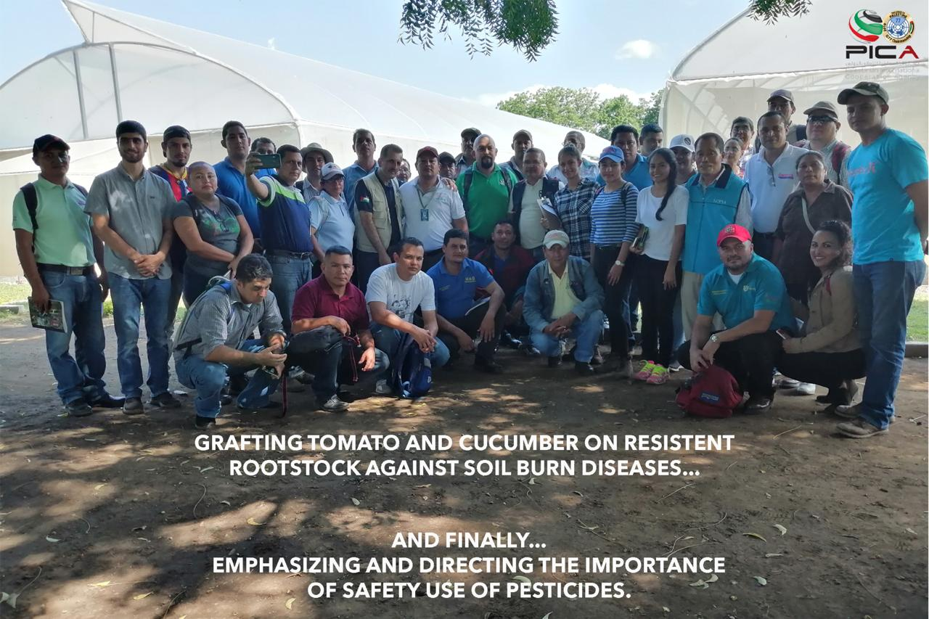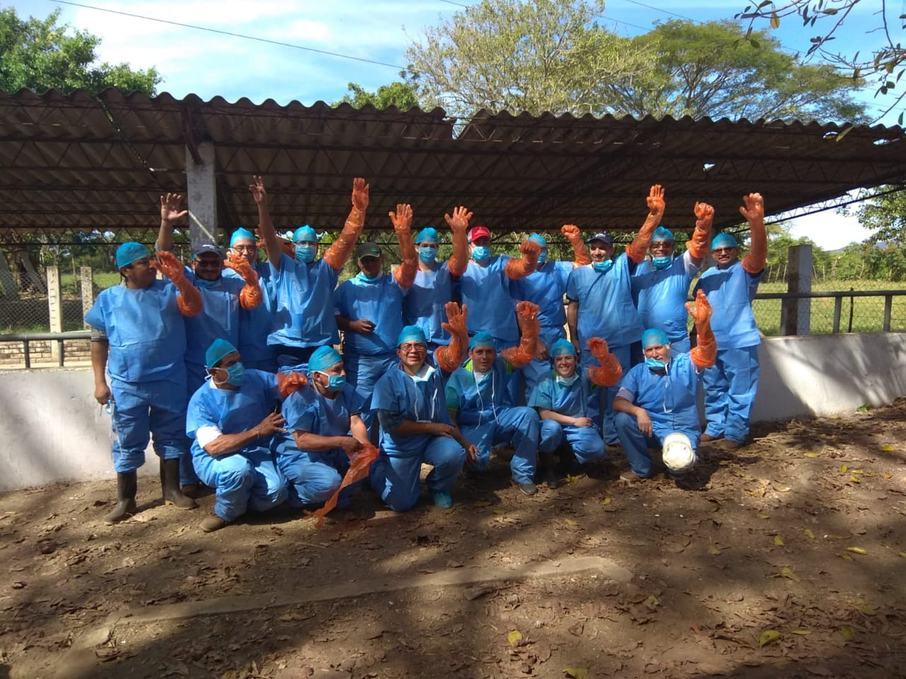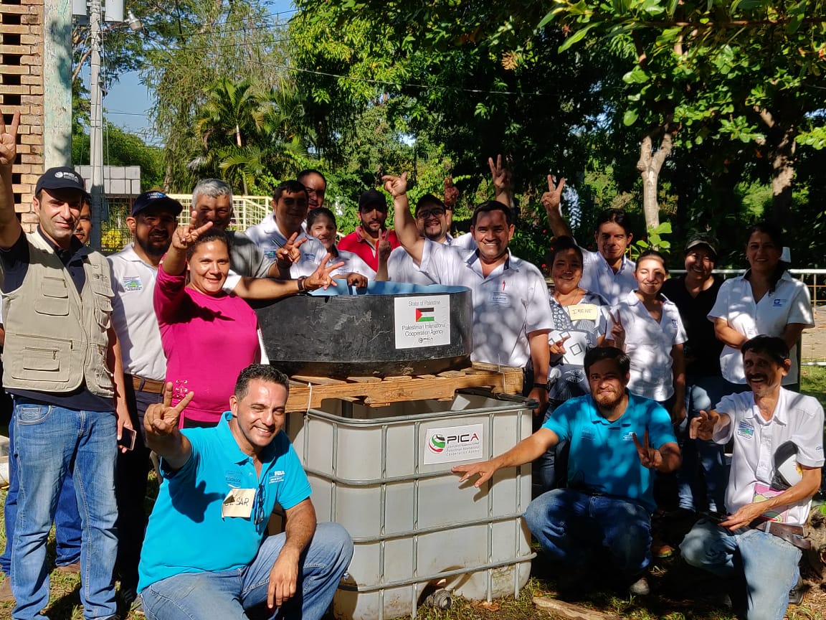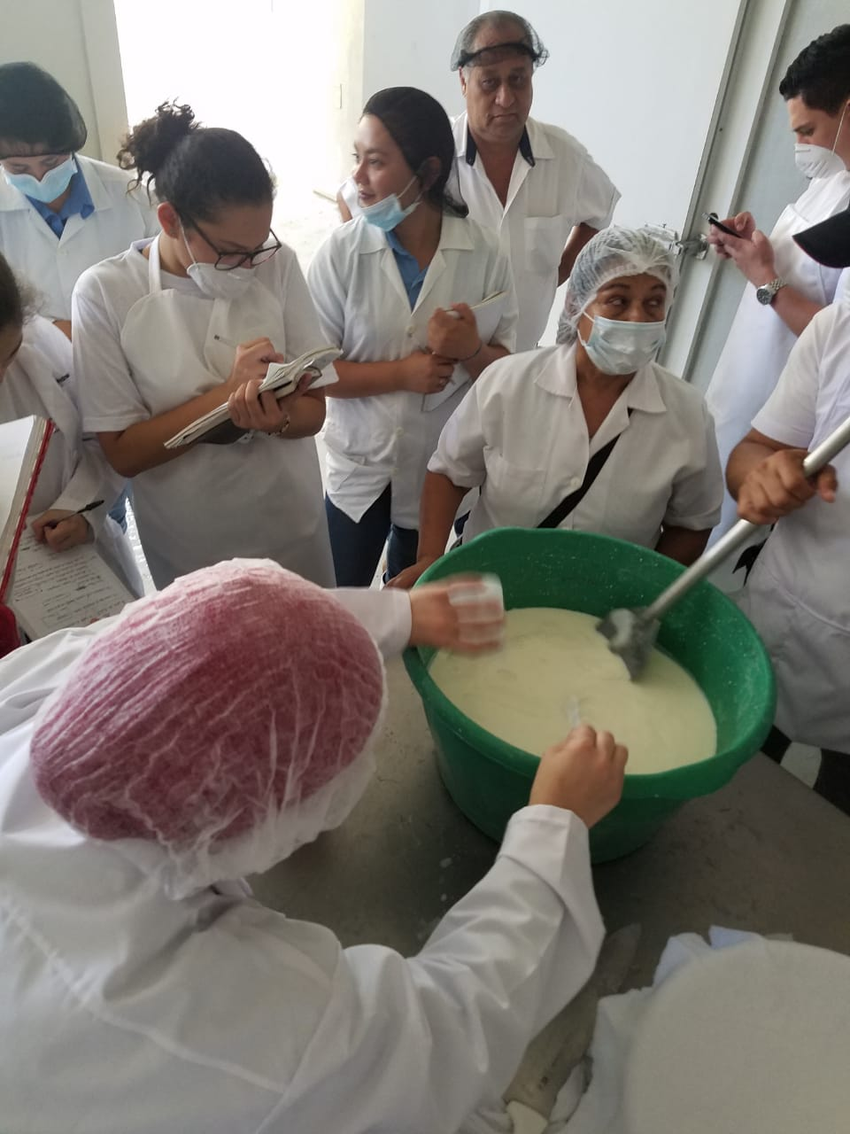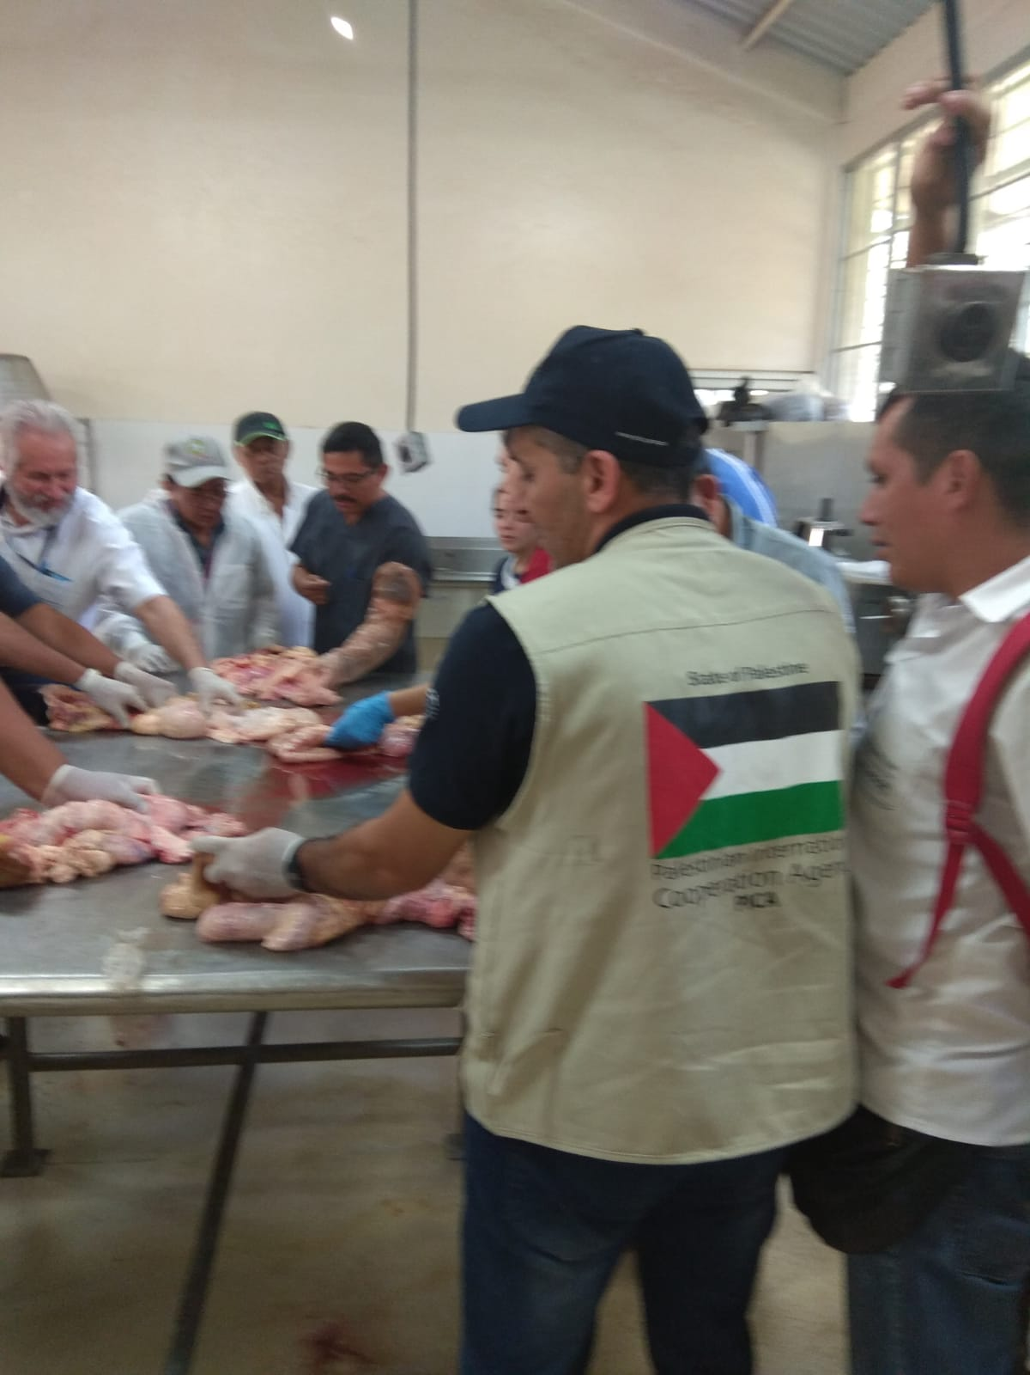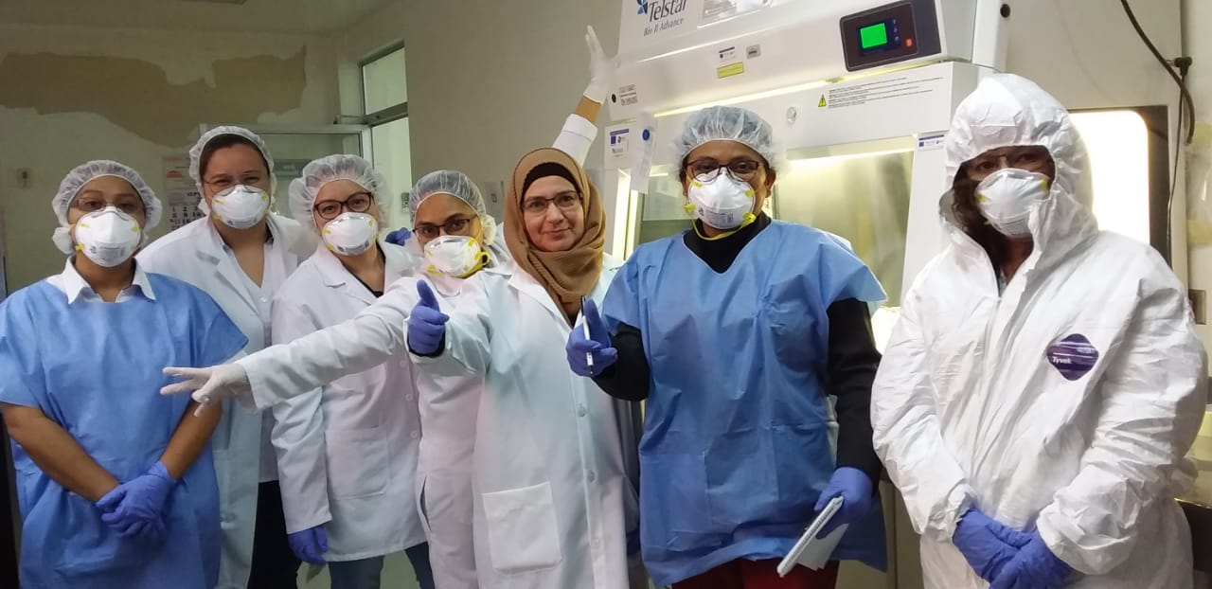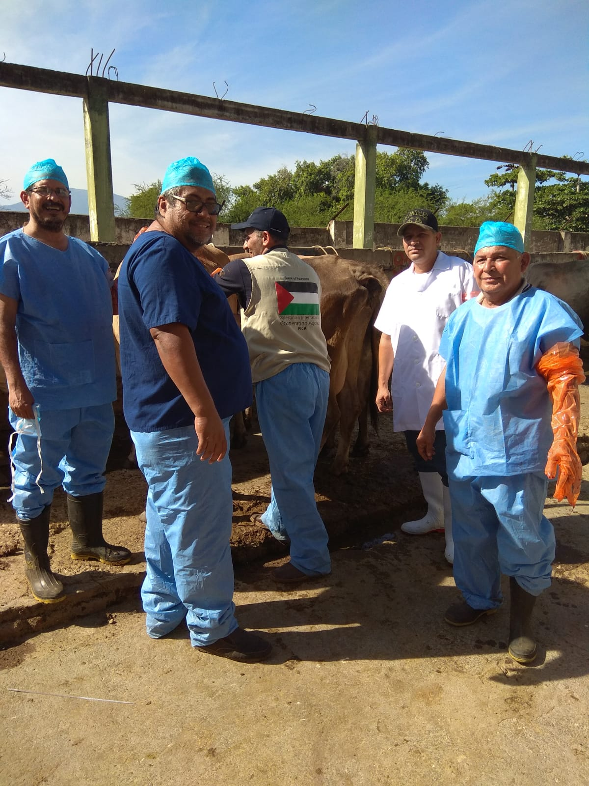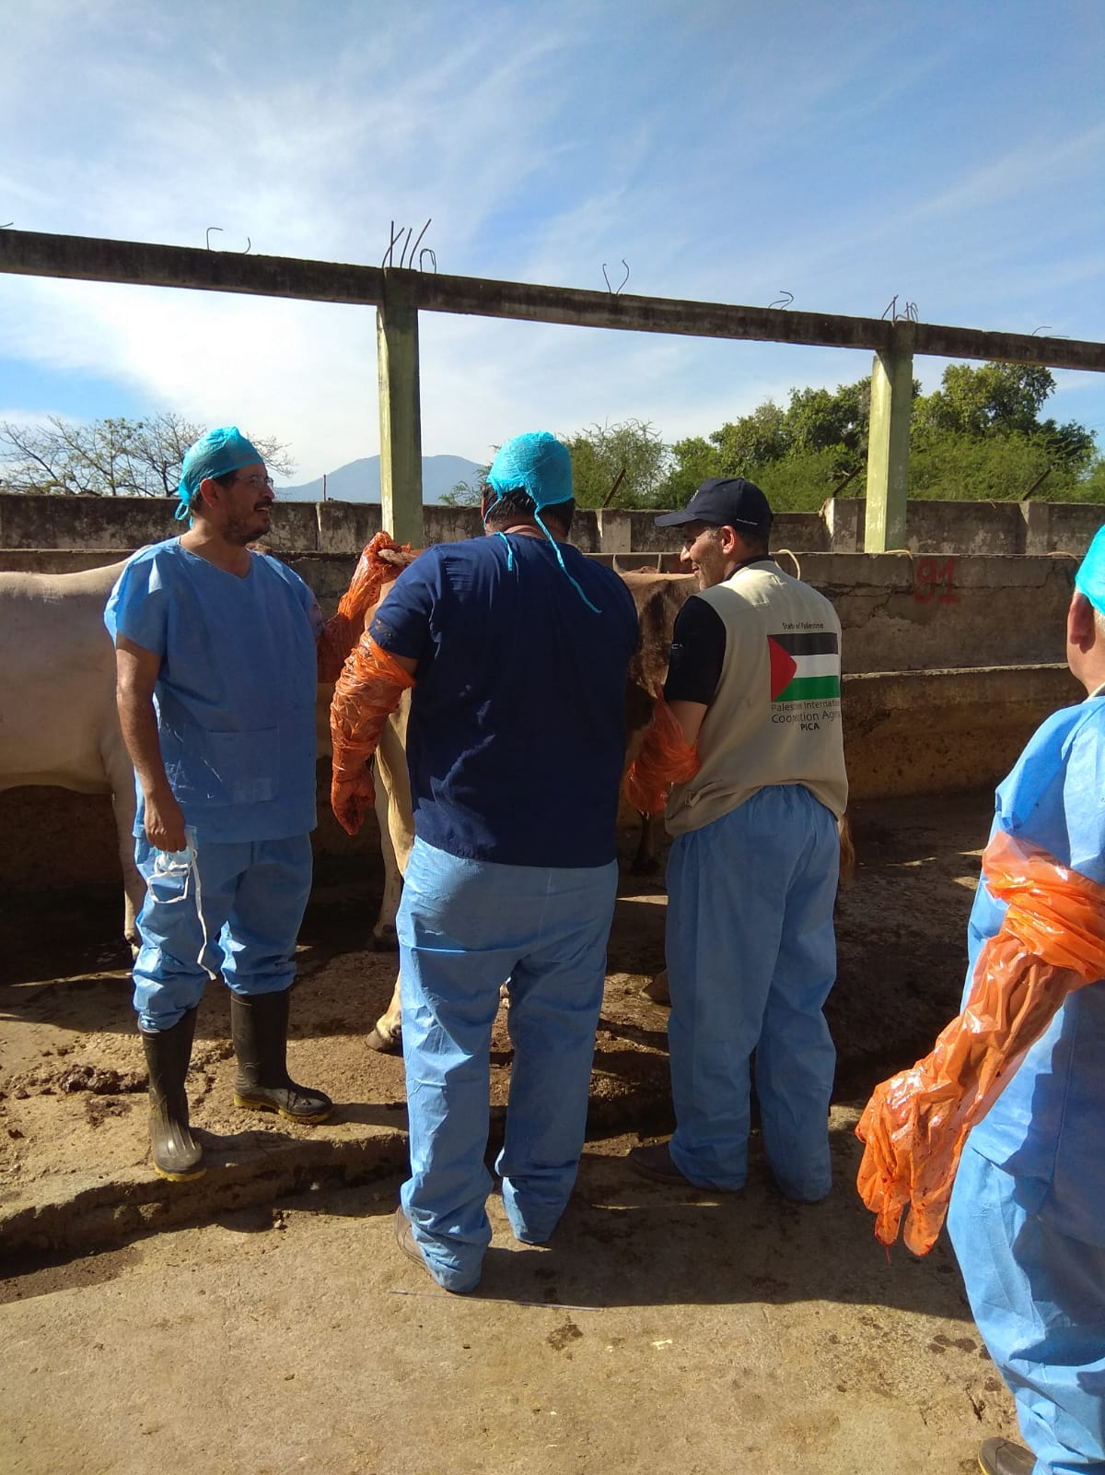

Related resources
What training manuals, guidelines, technical fact sheets, posters, pictures, video, audio documents, websites have been created as a result of identifying the good practice?

